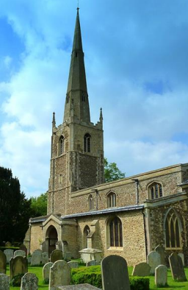
Y
R
O
T
S
I
H

L
A
C
O
L

E
R
I
H
S
N
O
D
G
N
I
T
N
U
H
K C
A
N
A
M
L
A

The Newsletter of the Huntingdonshire Local History Society Autumn 2022
0
.
2

e
c
n
e
c
i
l

c
i
r
e
n
e
g

s
n
o
m
m
o
C
e
v
i
t
a
e
r
C

r
e
d
n
u

d
e
s
n
e
c
i
l

,
r
k
c
i
l
F
-

)
d
e
p
p
o
r
c
(

d
r
a
l
l
a
B

n
o
s
a
J

)
c
(
Inside is our programme for Autumn 2022– Spring 2023, some online, some face-to-face. We hope you will find it interesting, and that you will join us for some or all of them
Philip Saunders, Chairman
www.huntslhs.org.uk
Registered Charity No. 290741
Lecture Programme 2022– 2023
In timing and venue this is our most mixed programme for some years, so please pay attention to when and where things are taking place, enter them in your diary, and leave home or work in good time as appropriate. We feel sure you can cope, indeed welcome, the variety. My apologies, though, for those who may receive this newsletter after the first event and who have not heard of it by another route. Unfortunately, some details took time to gel. Following the success of Zoom talks during the pandemic we again sticking to that format for the talks in January and February, but experimentally have added in some daytime activities.
Unless otherwise specified, meetings start at 7.30 p.m.
Wednesday 5th October. Huntingdon Town Hall
Goodliff Awards Presentation Evening
Our President, David Cozens, M.B.E., will give a short address on visits by previous King Charles to Huntingdonshire and present the awards It is an amazing variety of projects, popular and academic, spanning many centuries, types of history, covering the length and breadth of Huntingdonshire. We are inviting recipients of awards to briefly tell us about the awards and to bring with them something to display, be it a book they have produced or photographs of events, which we can look at and talk about individually over a glass of wine.
Do come to hear and congratulate the successful applicants for these awards
Wednesday 12th October, St Margaret’s Church, Hemingford Abbots
Disabled car parking at church, otherwise use Village Hall car park in High Street opposite seats, open specially for us.
Charles Beresford and David Yeandle
Hemingford Abbots: The History of a Parish through the Lives of its Clergy Charles and David are two of our members who have compiled a full record of the clergy who have served their local church from the 10th to the 20th century. It has produced a catalogue of some remarkable people, some of whom have left their mark on the parish and some of whom
barely knew it. They will be giving a presentation in the appropriate setting of the church itself.
Wednesday 9th November, Huntingdon Methodist Church Annie James
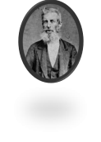
The Transportation of Huntingdonshire Criminals, 17th to 19th Centuries Annie James will be speaking about her monumental project to compile a biographical register of Huntingdonshire Criminals sentenced to transportation overseas. She has tracked down more than 700 such individuals in archives in the U.K. and in online versions of archives in Australia and elsewhere. The result is a fascinating insight into society and how it treated its more wayward members in the 18th and 19th centuries.
Friday 16th December, Huntingdon Town Hall
Social Evening with the Tapestry Singers
See extra sheet for information and booking.
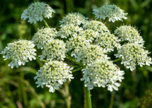
Wednesday 11th January 2023 (by Zoom)
Twigs Way, Garden Historian
Exploring Traditional Wildflower Names
Do you know your Keck from your Cow Mumble or
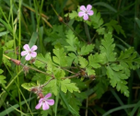
your Pilewort from your Pigs Pettitoes? Who was
Ragged Robin, what did Saxons use for their ale, and
y
a
why did foxes steal the Fairy Gloves?. This talk on
W

s
g
i
the origins of traditional wildflower names will reveal
w
T

.
the origins and meanings of wildflower names and discuss why they
H

r
D
were often spurned by the amateur botanists and antiquarians in
©
s
the late 18th and 19th centuries.
o
t
o
h
P
Zoom link will be circulated to members a few days before the talk.
2.30 p.m., Thursday 19th January
Afternoon visit to Huntingdonshire Archives to see Archive Sources for Landscape History
This will be a limited numbers bookable visit. Further information to follow at beginning of 2023. But if interested put this in your diary now.
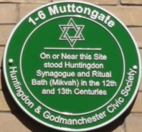
Wednesday 8th February (by Zoom)
Emma Harris
1-6 Muttongate: the Inside Story
Dr Emma Harris is Director of Studies at the Woolf
Institute (Cambridge). Emma will be speaking about her
late father Mark Harris' quest to discover the location of
medieval Huntingdon's synagogue and ritual bath
(mikveh) that led to the erection of the plaque on the
new development off St Clement’s Passage in 2016.
Zoom link will be circulated to members a few days
before the talk.
2.30 p.m., Wednesday 22nd February, Huntingdon Methodist Church Presentation and Workshop on small finds from the A14 Archaeology
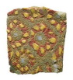
Now the new road is open, the immense archaeological project, the
y
g
o
l
amazing finds of which we heard about in 2018, may seem a long time
o
e
a
h
ago, but the post-excavation phase continues, identifying and assessing
c
r
A

n
those discoveries. We have arranged for experts from the Museum of
o
d
n
o
London team to come and tell us about the ‘small finds’ and to lead a
L

f
o

workshop on them. A PowerPoint presentation will be open to all, the
m
u
e
s
workshop that follows to a discrete number only, requiring booking.
u
M
©
More details to follow
Wednesday 8th March, Huntingdon Methodist Church Sadie Macmullon
Fletton - Building the Brickopolis
Commencing with research into migration to supply the needs of the brick industry in Fletton 1841-1911 for her Leicester University PhD, society member Sadie has branched out into wider study of the community and has now both registered a ‘One Place’ study, published several articles and writes a monthly blog. This talk focuses on the development of the
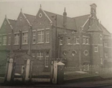Fletton Board School,
industrial suburb of Peterborough and the people who made it.
Wednesday 19th April, venue to be announced Nicholas Orme
characteristically brick-built, industrial
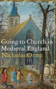
We are very fortunate to have secured Professor Orme, author of the
shortlisted Wolfson History Prize 2022 and Daily Telegraph Book of the Year 2021 Going to Church in Medieval England to come and talk about
researching that very subject. More details to follow.
Wednesday 10th May, venue to be announced
Annual General Meeting with a short talk &/or display
Details to be circulated in the Spring.
Writing for Records
Would you like to write an article for the Records of Huntingdonshire? Contributions are always very welcome. Whatever the topic, there should a focus on content relating to the historic county of Huntingdonshire and we hope to be offered original material, not published elsewhere. Brief articles, say 6 sides of A4, are preferable but the treatment of some topics may merit more space than others. Prospective contributors should contact the editor, Richard Halliday (01480-455669) for an early opinion on likely acceptability and guidance on house style. Submissions should be in Word and photographic illustrations as jpeg files. The society expects to have copyright.
Goodliff Awards 2023
Do you need help to complete a local history project? You can apply to our Goodliff Award Scheme. We provide funding to individuals, societies, schools and groups who need support. Over the past 25 years, the Society has contributed £150,000 to over 250 projects. Funding may be given towards publication costs for books, leaflets or display panels; the purchase of equipment; conservation or purchase of artefacts or documents etc.
For more information and to find an application form, visit the Goodliff Awards section of the Huntingdonshire Local History Society website www.huntslhs.org.uk or email goodliff.awards@gmail.com The deadline for the receipt of applications is 31st March.
Subscriptions
New subscriptions during Autumn 2022 cover all 2023. Otherwise renewals are due on 1st January, £10 single, £15 double, indisputably good value. Please renew promptly through our treasurer, David Smith. If you are a UK taxpayer, he can arrange a Gift Aid declaration, thereby increasing the society’s income. Tell him too if you have you have made a declaration in the past but no longer earn enough (£12,570) to pay income tax.

