Buckden Local History Society

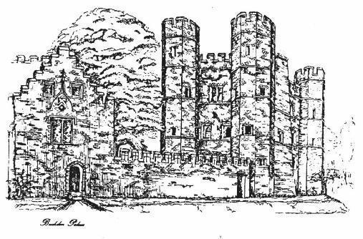

Programme
2023-2024

Meetings are held at
Millard Suite
Village Hall
at 7.30pm
on
the first Wednesday of the month

September 6 - 2023
Transportation of Criminals in Huntingdonshire by Annie James

Annie received a Goodliffe Award in 2022 to research and document information and records of Huntingdonshire convicts that were sentenced to deportation. The records will be lodged in the Huntingdonshire Archives once completed.

October 4
5-9 Church Street by Brendan Henry
Brendan talks about the renovation of one of Buckden’s historic houses.

November 1
The History of local sport by Nigel Fenner
Nigel talks on the history of local sport focusing primarily on the 19th century.

December 6
Did Cromwell really cancel Christmas? by Stuart Orme
Stuart reveals the fascinating story behind the myth of how the festive season was outlawed in the 1640s.

January 3 2024
Buckden Palace and Towers by Barry Jobling

A history of the Bishops of Lincoln’s Palace, Buckden’s most iconic group of buildings, from the 15th century to date, using some previously unseen documents and illustrations.

Chairman: Richard Storey
Vice Chairman: Barry Jobling
Treasurer: Eric Nash
Secretary: Richard Storey
Committee Members:
Clive Thomson
Nicky Gibbs
Les Button
Buckden Local History Society is affiliated to the Cambridgeshire Association for Local History.
For more information on the Society please contact the Secretary at Buckdenhistory@gmail.com
see our website at https://www.buckdenhistory.co.uk/
or use the QR code below.
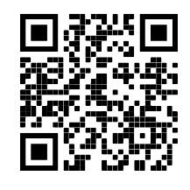

February 7
If you can be anyone other than yourself who would you be?! by John Upham

We wait with anticipation!

March 6
The Admiral, The Rector and Long John Silver by David Longman
David recounts tales from Bedfordshire Churches

April 3
Malta in WW2 by Linda Upham
Linda looks at the period leading up to the award of the George Cross, with eyewitness accounts by those who were children at the time.

May 1
St Neots in the time of Jane Austen by Liz Davies
Liz reveals the fascinating Regency period 1811 – 20, through the lives of local people. Discover local links with the battle of Waterloo, the assassination of a British Prime Minister, the struggle against the international slave trade and the story of the Eynesbury Giant

June 5
AGM and Cockney Rhyming Slang by Barry Jobling
A short, light-hearted amble through a 20th century Londoner’s vocabulary, where it comes from, what it means and when to use it (but only if you were born within the sound of St. Mary-le-Bow church bells)!

Fees:
Members £20
Joint Family £35
Visitors £5

